St Matthew’s School

9 Glyde Street

(PO Box 456)
Narrogin. WA. 6312
Ph (08) 9881 2154
Fax (08) 9881 2135
Emailadmin@matthews.wa.edu.au
Website: www.matthews.wa.edu.au

Dear Year One Parents,

Next term is our exciting Mary Poppins musical on Friday 18th November!

In the Year One scene, the students will be going through the park with kites.

Mrs Hastie has been working very hard in planning our costumes. We ask that you dress your child in brightly coloured clothes, such as the vibrant colours on the kites below.
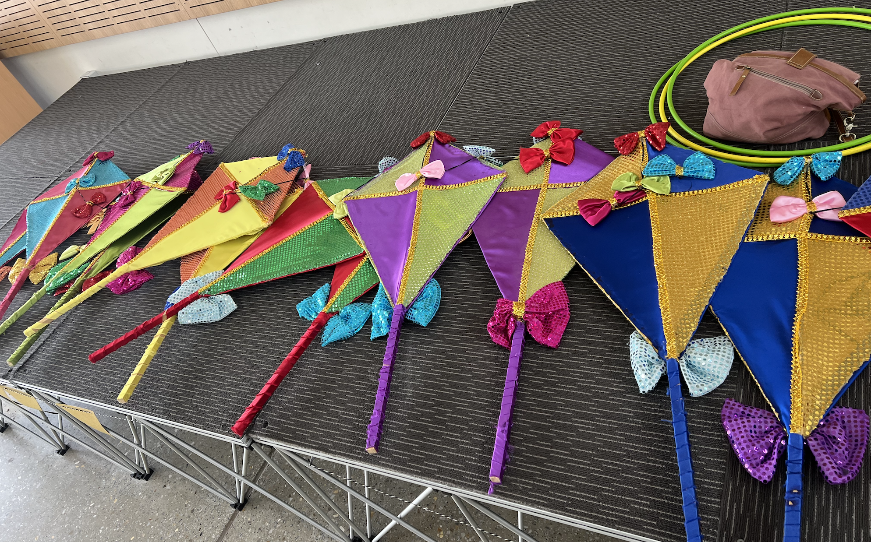

If possible please dress your child in block colours, with minimal pictures and prints. Plain, brightly coloured tops and bottoms, as well as glitter are encouraged. The musical is set in London in 1900 and big hats are also encouraged. Examples as per below.
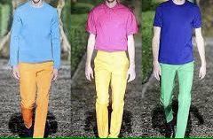

Please contact Carrie by email if you have any questions.

Thank you,

Carrie English
Carrie.english@cewa.eu.au

