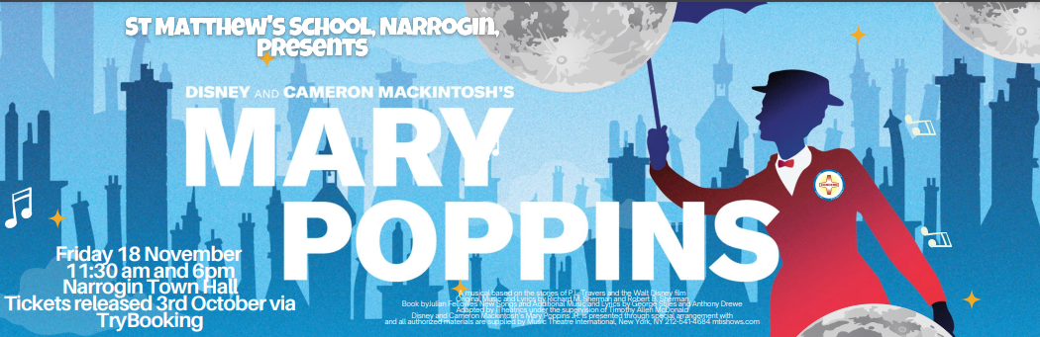
Dear Parents and Carers,
The school performances of Mary Poppins are fast approaching. Please see below for information regarding the final practices and the arrangements for the performances:

Monday 14 November
- All costumes to be brought to school

Wednesday 16 November
- Students will get dressed in their costumes at school, prior to walking to the Narrogin Town Hall at 10:15am. This includes Kindy students.
- Students return to school at approximately 1:00pm
- Students will conclude the day at 3:00pm as usual

Thursday 17 November
- Students will get dressed in their costumes at school, prior to walking to the Narrogin Town Hall at 10:15am.
- Kindy students are not required for this rehearsal, however, parents are welcome to bring them if they would like to be involved.
- Students return to school at approximately 1:00pm
- Students will conclude the day at 3:00pm as usual

Friday 18 November Matinee – 11:30am
- Students will get dressed at school prior to walking to Town Hall at 10:15am
- Kindy students to assemble at the Reception Centre by 11:00am
- Students perform at 11:30am
- Students return to school at approximately 1:00pm
- Students will conclude the day at 3:00pm as usual
- Students will take their costumes home

Friday 18 November Evening – 6:00pm
- Students will need to come dressed in their costumes to the Reception Centre (next to Town Hall) at 5:45pm
- Kindergarten students may join this performance, but it is not an expectation.
- Parents to collect their children from the Reception Centre as directed at the end of the performance. Children will only be released to their own parents unless class teachers have been informed in writing of an alternative arrangement.
All ticket holders must produce their ticket to gain entry to both the matinee and the evening performances on 18th November. There are still tickets available for the Matinee. Please use the link on the school app to secure these.

Thanking you,

Susan Milton

